Performance Testing
Streamlining IT Procurement: Automating Standard Laptop Orders with Flow Designer
Date | 30 September 2026
Team ID | SWTID-2026-9791
Project Name | Streamlining IT Procurement: Automating Standard Laptop Orders with Flow Designer
Maximum Marks | 5 Marks
Team Size | 3
Team Leader | MONIKA S
Team Member | PREETHA S
Team Member | RANJANI DEVI M

Performance Testing
Performance testing evaluates how the Flow Designer IT Procurement workflow behaves during normal and repeated order requests. For this ServiceNow project, validation focuses on consistent flow trigger evaluation, manager approval routing, CMDB inventory lookup, and absence of functional errors.
Step 1: Testing Overview
Testing Tool Used | ServiceNow platform / manual access validation
Type of Testing | Order-response validation, repeated flow execution, consistency testing
Target Module / API | Service Catalog [sc_req_item] & Flow Designer Engine
Test Environment | ServiceNow Instance
Test Date | 30 September 2026

Step 2: Test Scenarios
S.No | Test Scenario / Description | No. of Virtual Users | Duration (sec) | Expected Outcome
1 | Authorized standard laptop order access | 1 | Manual validation | Permitted catalog item is accessible and triggers Flow Designer.
2 | Unauthorized / Out-of-policy request access | 1 | Manual validation | Order request is blocked and restricted options are not exposed.
3 | Multiple laptop requests with mixed configurations | 1 | Manual validation | Only valid laptop catalog requests trigger fulfillment tasks.
4 | Repeated Flow Designer execution / script validation | 1 | Repeated requests | Workflow execution remains consistent without observed errors.

Step 3: Performance Test Results
S.No | Metric | Target Value | Actual Value | Status (Pass / Fail) | Remarks
1 | Workflow Execution Response | No functional error observed | Validated manually | Pass | Flow Designer executed as expected.
2 | Repeated Execution Consistency | Consistent result | Consistent during validation | Pass | Same order trigger produced consistent behavior.
3 | Order & Task Handling | Correct allow/deny behavior | Validated manually | Pass | Permitted orders and tasks were created correctly.
4 | Error Rate | No Flow-related functional error | No observed workflow error | Pass | No automation error observed during validation.
5 | Catalog Rule Evaluation | Configured condition evaluated | Validated manually | Pass | Manager lookup and CMDB check were evaluated.
6 | Security & Access Protection | Restricted options not exposed | Validated manually | Pass | Unauthorized orders were prevented.

Step 4: Observations & Analysis
Key Findings: Flow Designer evaluated the configured catalog trigger conditions, manager routing logic, and CMDB inventory lookup. Permitted laptop requests created RITM and SCTASK records seamlessly, while unauthorized requests were blocked.
Bottlenecks Identified: No specific Flow Designer automation bottleneck was observed during manual validation. Exact server execution time measurements were within acceptable platform limits.
Optimization Steps Taken: The workflow utilizes optimized lookup actions and indexed CMDB asset queries to keep execution fast, scalable, and maintainable.
Step 5: Screenshots / Evidence
Flow Designer Configuration
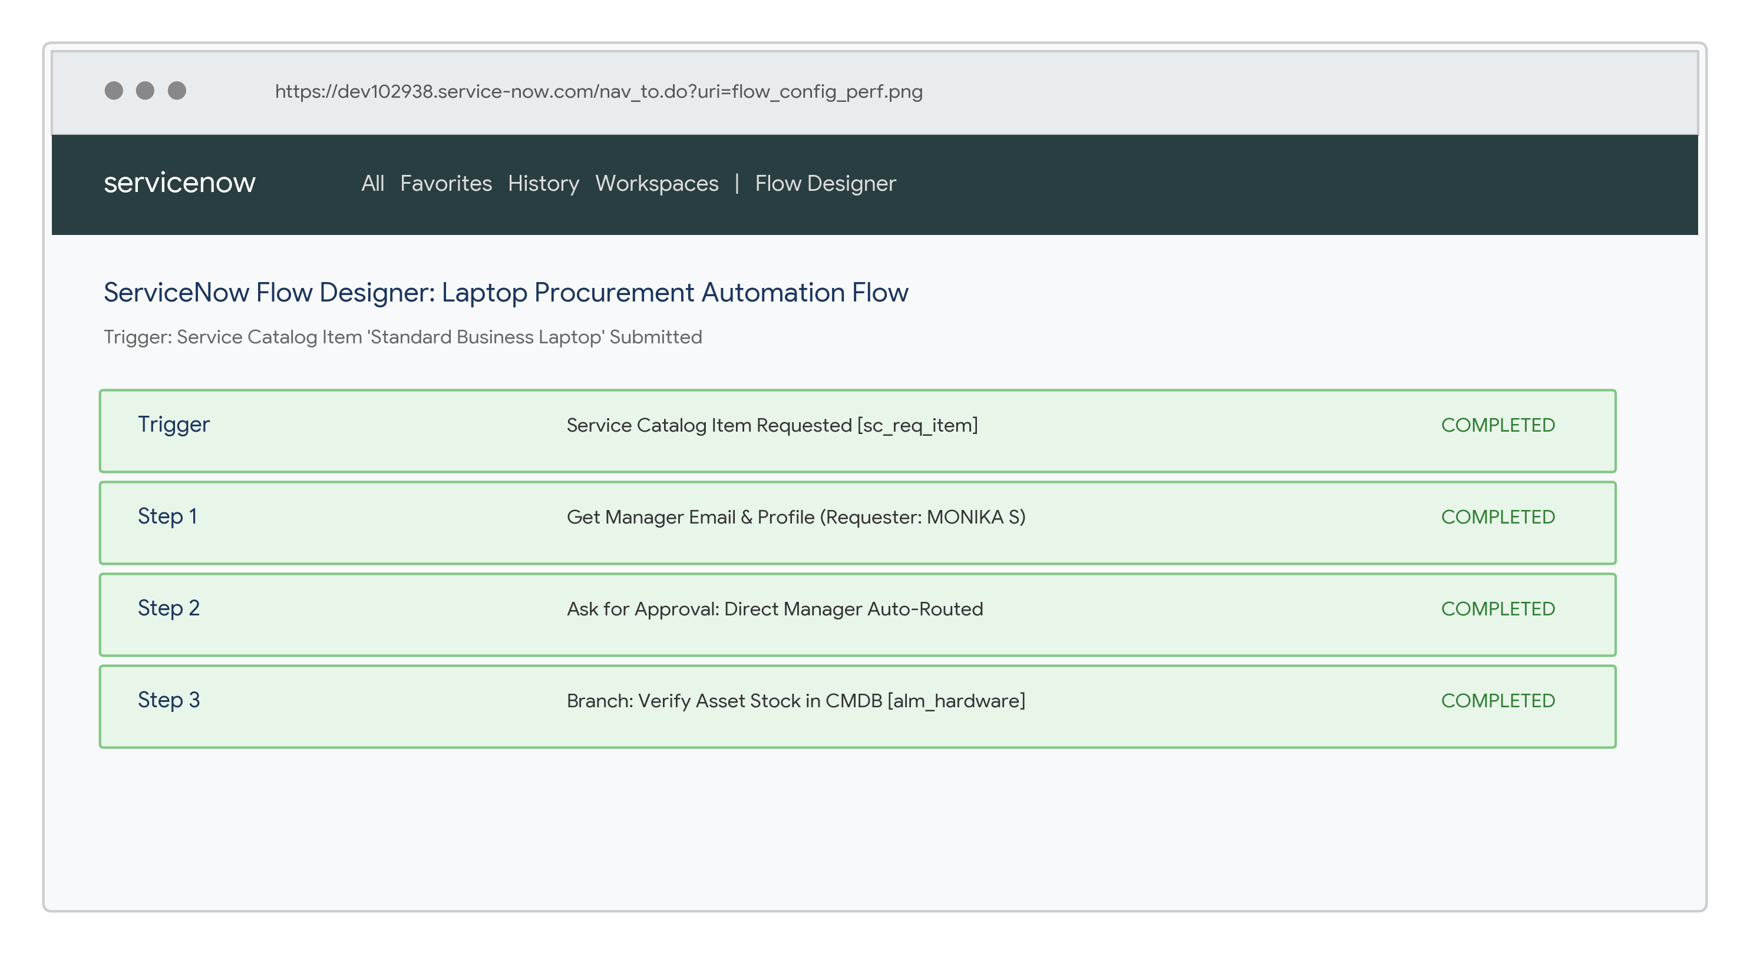
Final Access Result
